Linux Programming : Assignment-5
Name : Vigneshwaran P
Class:3C
USN : ENG24CY0069

- What is a shell in Linux OS? How many categories of shell is currently exists in Linux? Why bash shell is very popular in Linux distribution?
Soln:
A shell in Linux is a command interpreter that allows users to interact with the OS.
Types: Bourne Shell (sh), Bash, Korn Shell (ksh), C Shell (csh), Z Shell (zsh).
Bash is popular because it supports command history, auto-completion, scripting, and backward compatibility with Bourne Shell.

- What does the ls -Z command display?
Soln:
Displays SELinux security context (user, role, type) for files.
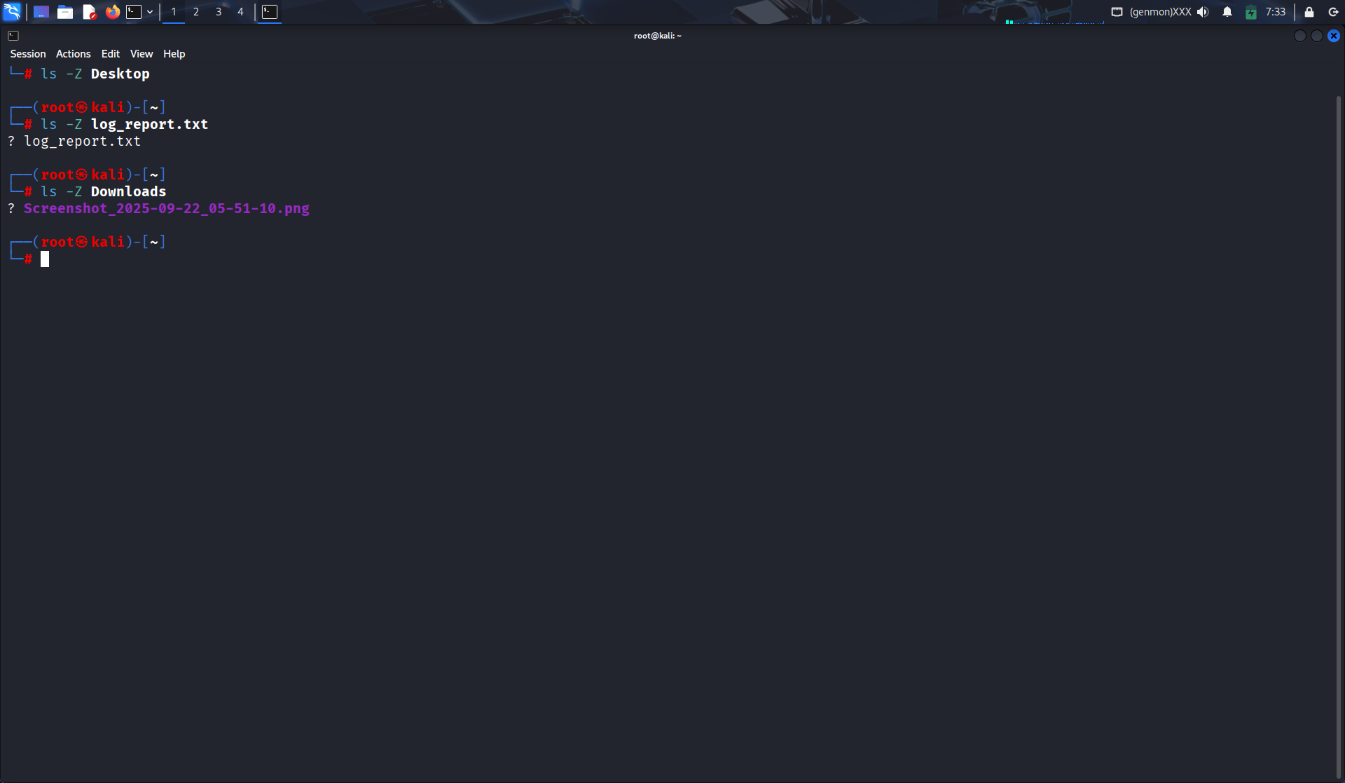

- Write a command to list all hidden files in the current directory.
Soln:
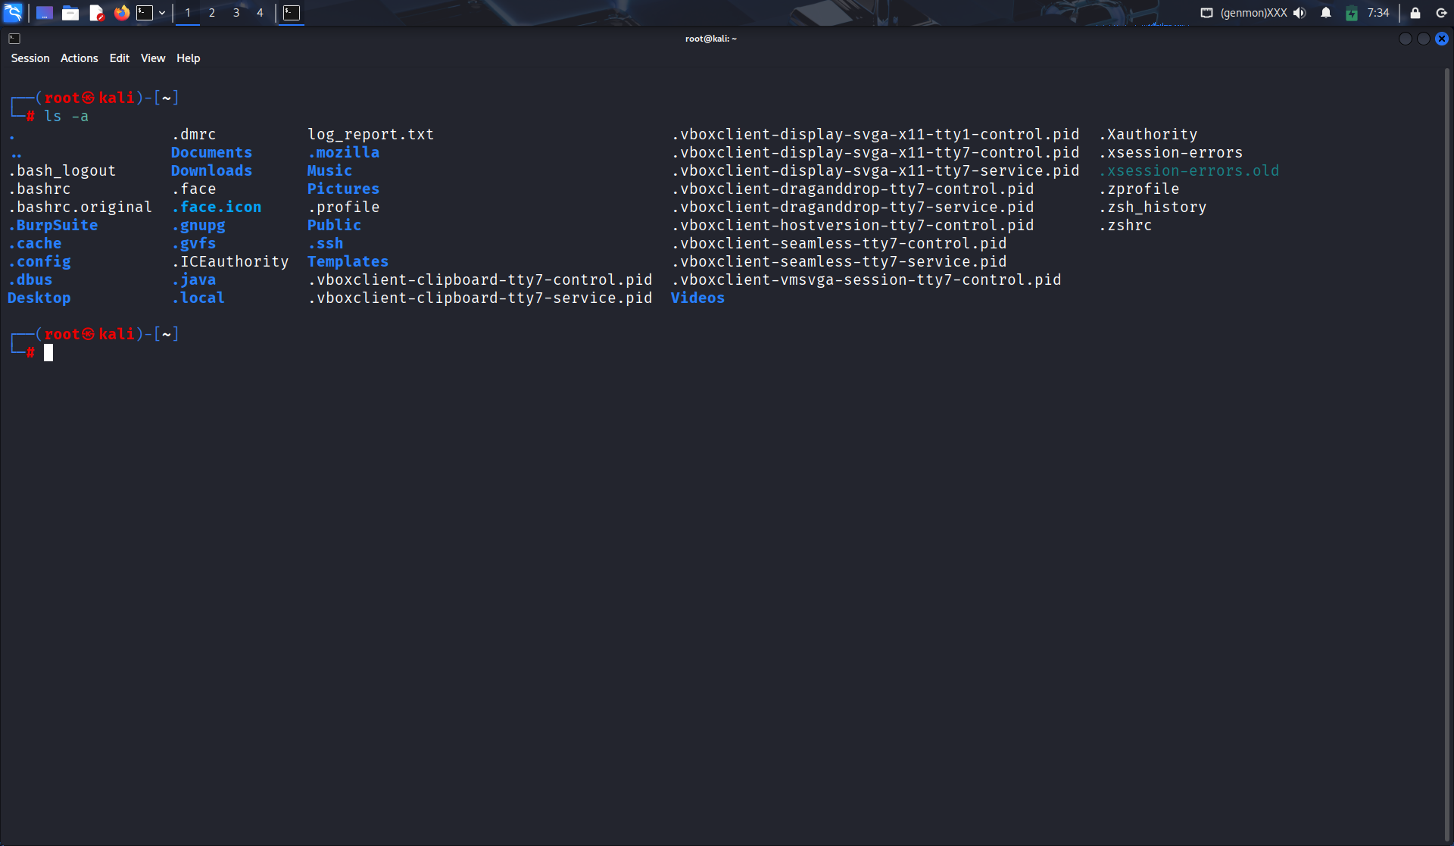

- Explain the difference between hard links and soft links (symbolic links) in Linux.
Soln:
Hard link: Points directly to file data (same inode).
Soft link (symbolic): Points to another file name (different inode).

- A file has permissions -rwxr-x--x. Explain who can read, write, and execute it.
Soln:
Permissions: -rwxr-x--x
- Owner: read, write, execute
- Group: read, execute
- Others: execute only

- Write the command to change the group ownership of a file data.txt to group staff.
Soln:
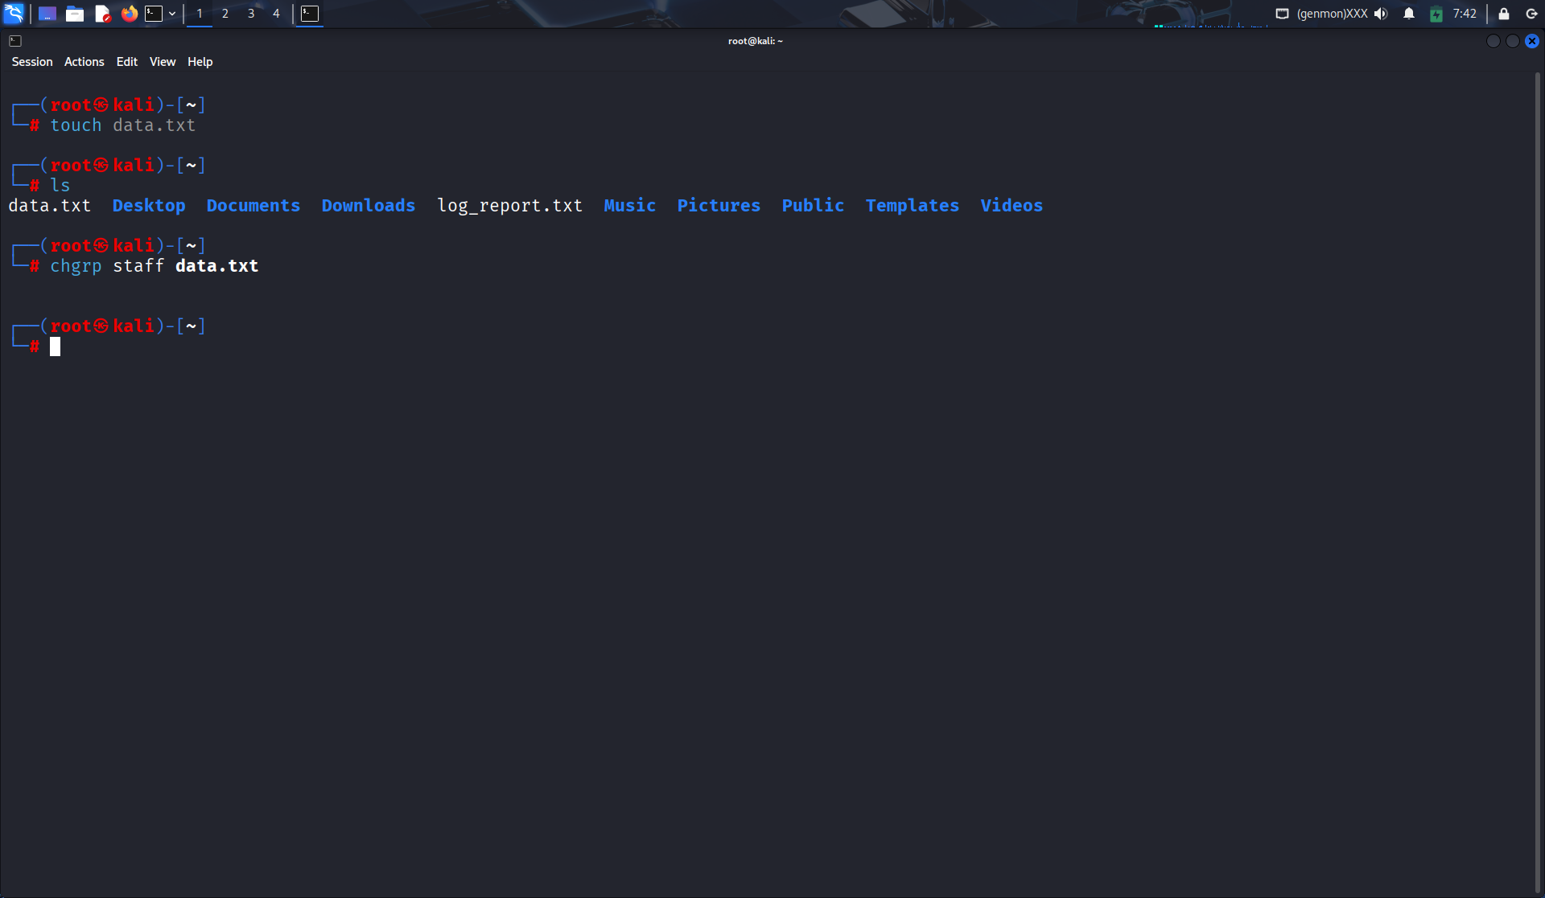

- Why is it dangerous to give 777 permissions to a file? Explain with an example.
Soln:
777 gives read, write, execute to everyone → unsafe because anyone can modify or delete files.
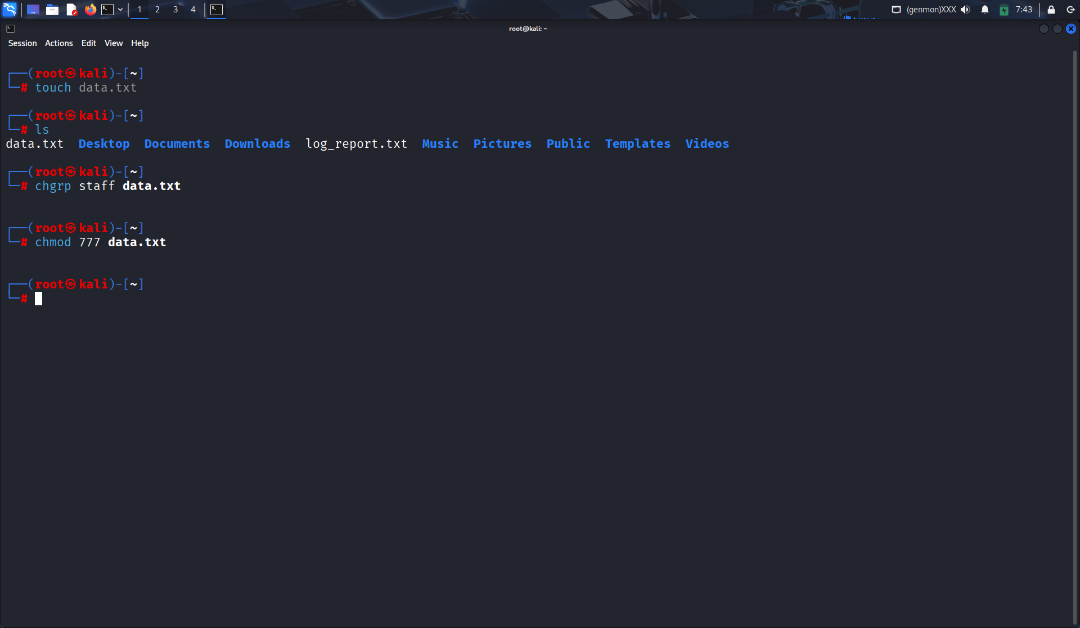

- What is the difference between apropos (i.e., man -k) and whatis (i.e., man -f)?
Soln:
apropos (or man -k) → searches keywords in man pages.
whatis (or man -f) → gives one-line description of a command.
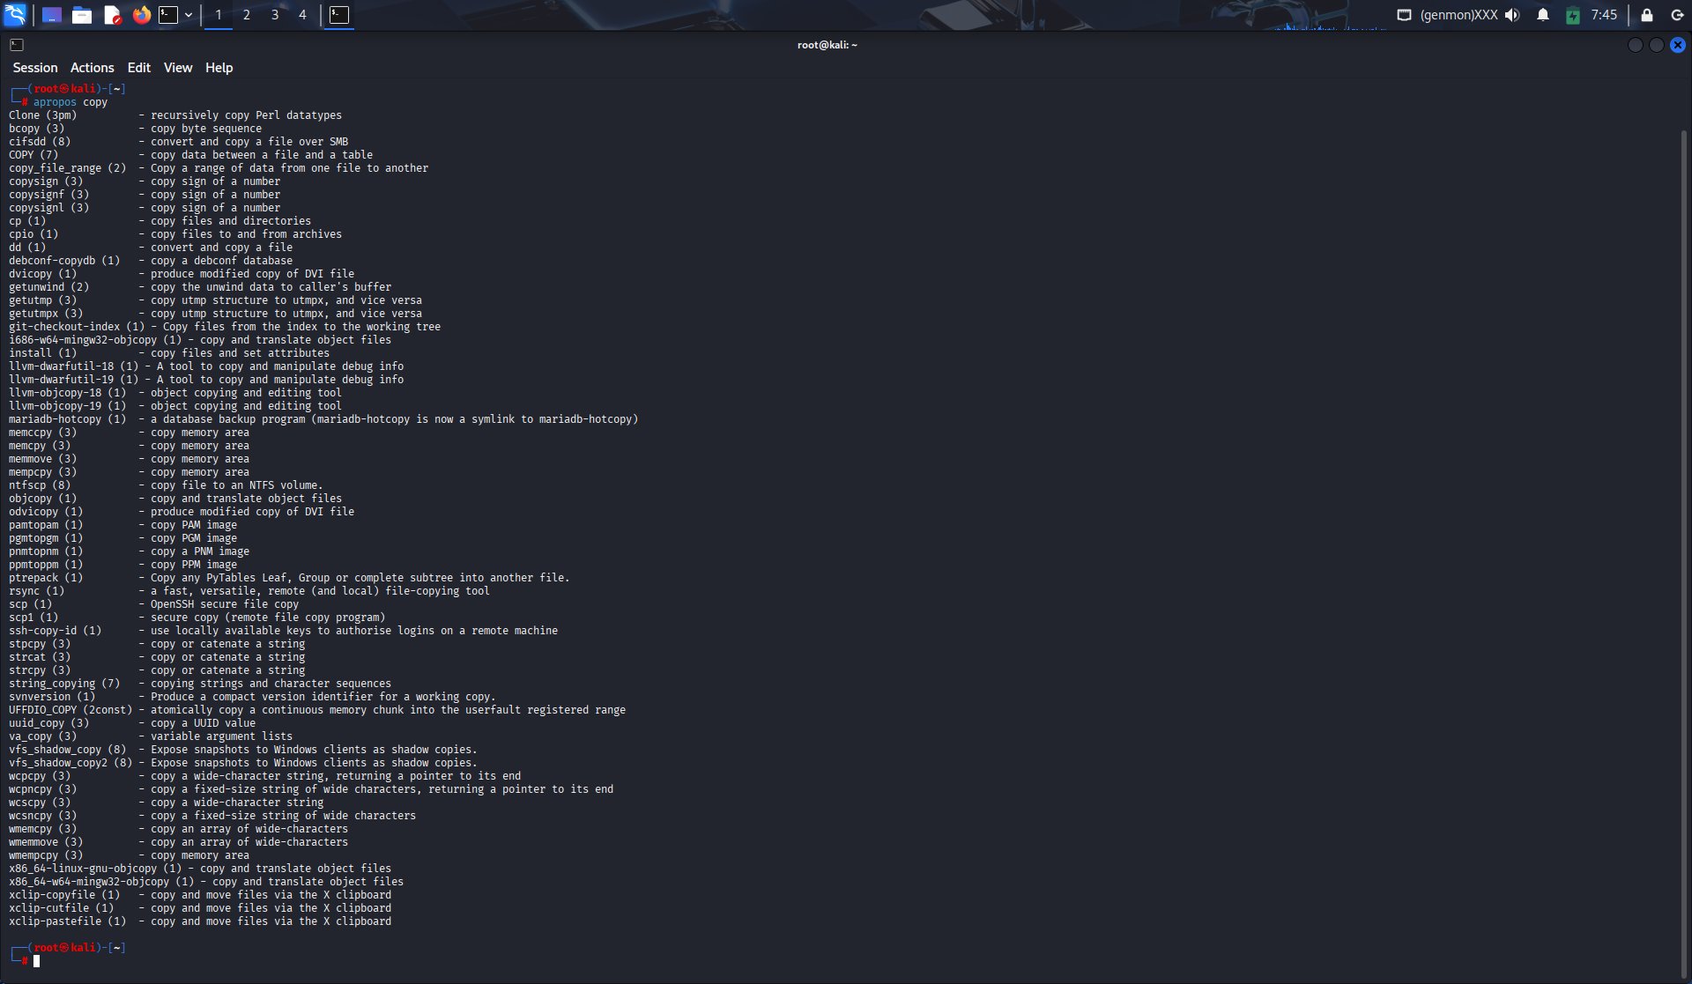
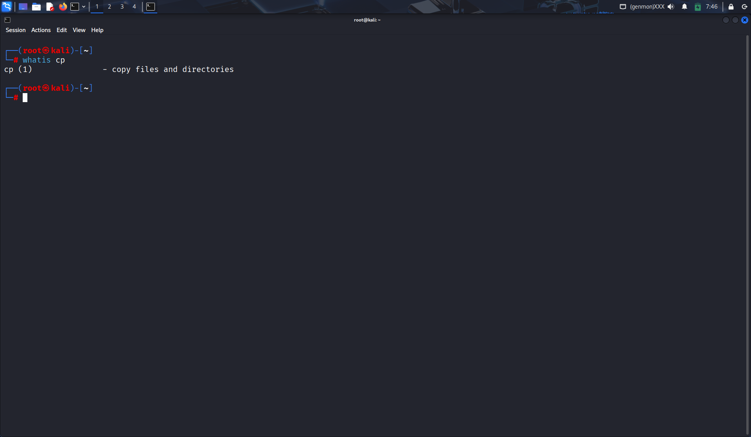

- Write a command to redirect the error output of a command to a file named error.log.
Soln:
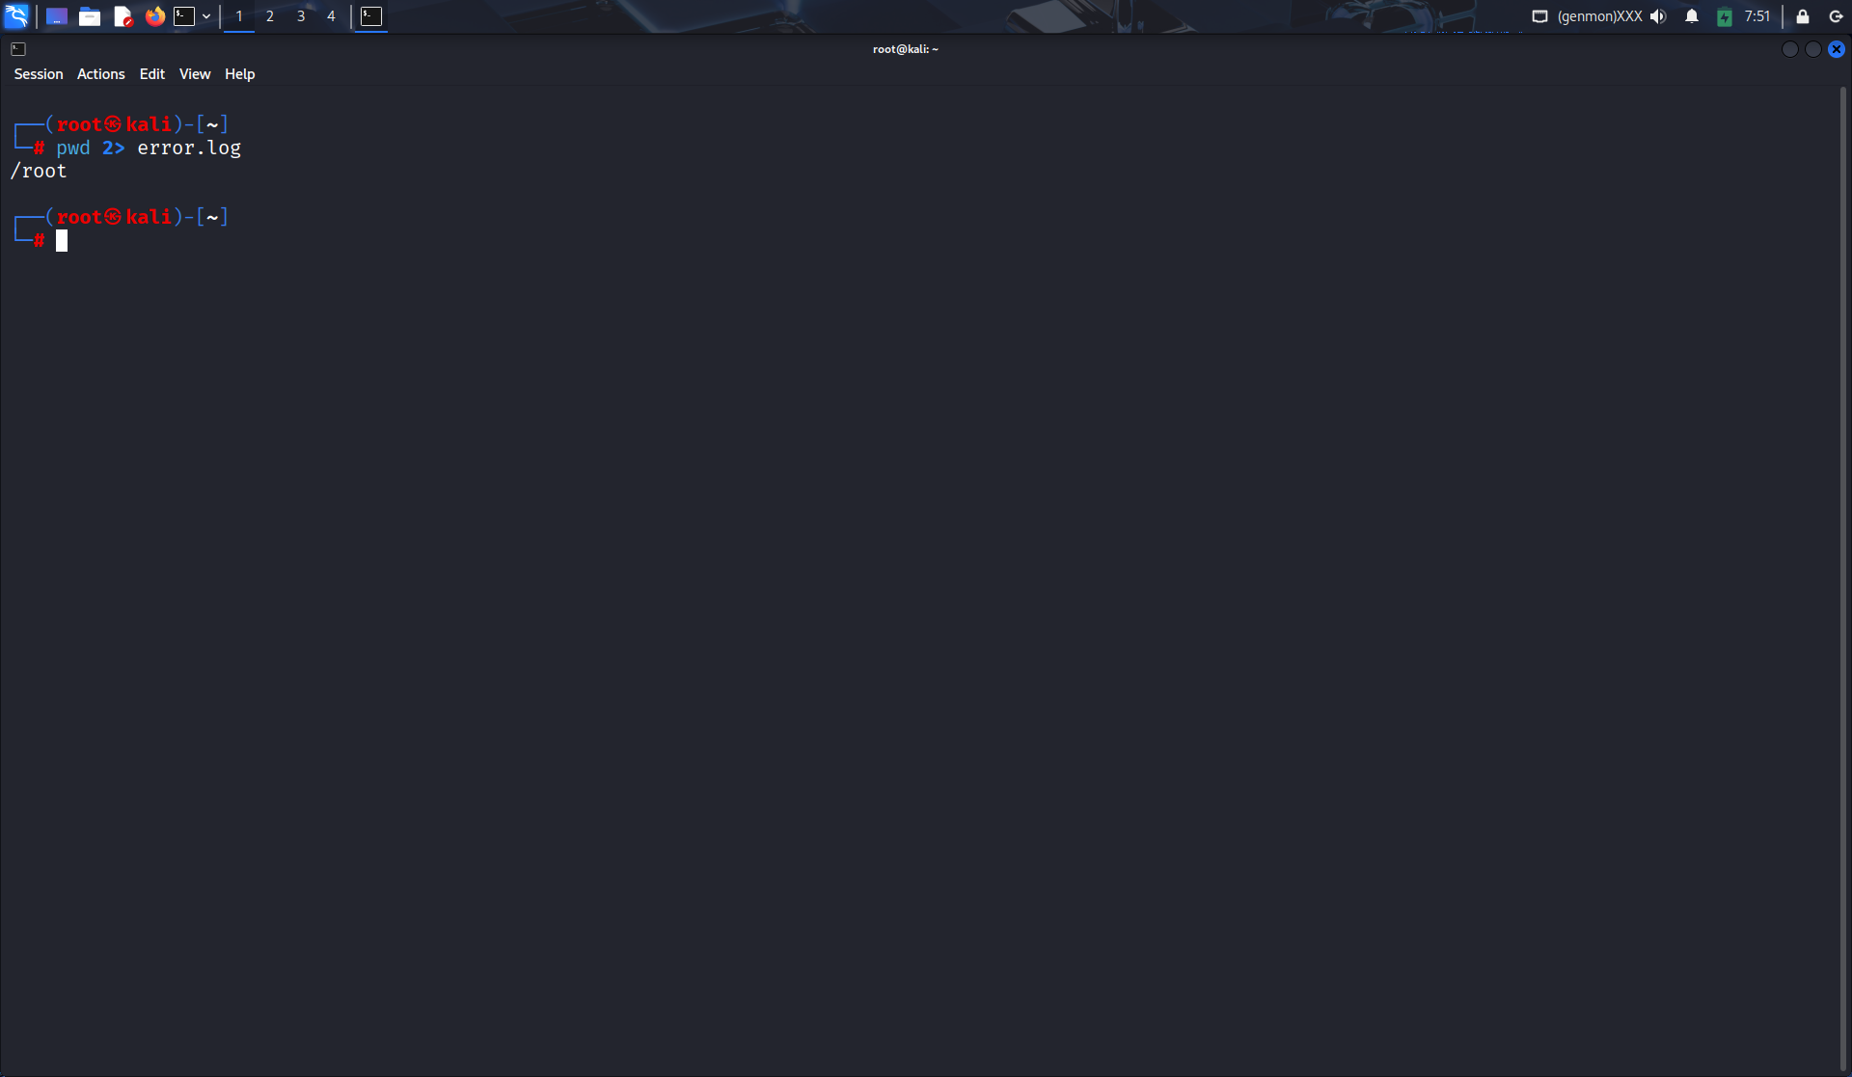

- How can you use the tee command to append output to a file instead of overwriting it?
Soln:
